Contents

What is Entity Framework? 1

Basic Workflow in Entity Framework 1

Context Class in Entity Framework 2

Appsettings.json 3

dependency injection of the DbContext 3

Model 4

Configuring DbContext to use connection string 5

Initialize the DbContext in main method 6

Add initial migration 7

Update database schema 8

Azure Database 8

LINQ Method syntax vs Query syntax: 9

What is Entity Framework?

Entity Framework is an open-source [ORM framework](http://en.wikipedia.org/wiki/Object-relational_mapping) for .NET applications supported by Microsoft. It enables developers to work with data using objects of domain specific classes without focusing on the underlying database tables and columns where this data is stored. With the Entity Framework, developers can work at a higher level of abstraction when they deal with data, and can create and maintain data-oriented applications with less code compared with traditional applications.

# Basic Workflow in Entity Framework

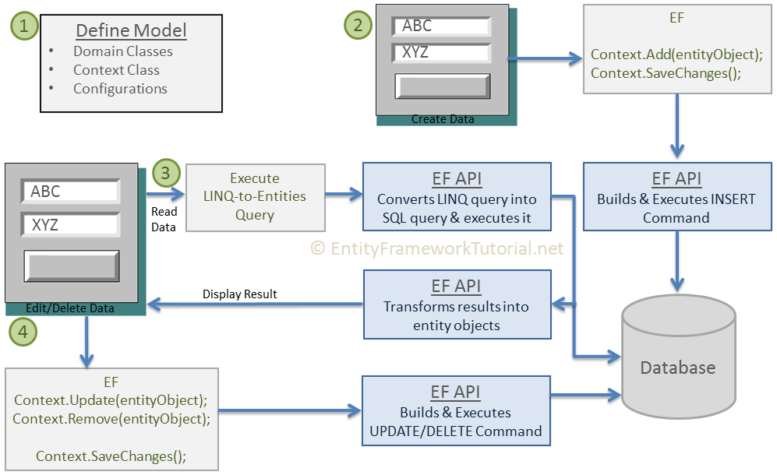

1. First of all, you need to define your model. Defining the model includes defining your domain classes, context class derived from DbContext, and configurations (if any). EF will perform CRUD operations based on your model.
2. To insert data, add a domain object to a context and call the SaveChanges() method. EF API will build an appropriate INSERT command and execute it to the database.
3. To read data, execute the LINQ-to-Entities query in your preferred language (C#/VB.NET). EF API will convert this query into SQL query for the underlying relational database and execute it. The result will be transformed into domain (entity) objects and displayed on the UI.
4. To edit or delete data, update or remove entity objects from a context and call the SaveChanges()method. EF API will build the appropriate UPDATE or DELETE command and execute it to the database.

# Context Class in Entity Framework

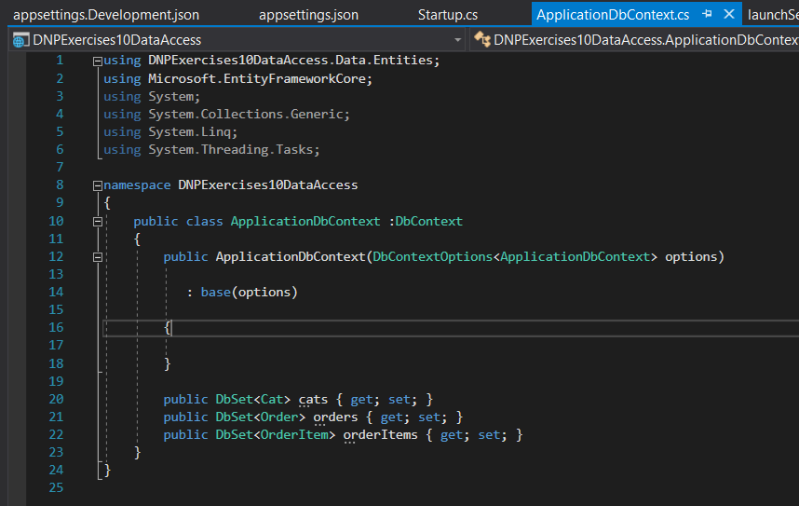

# Appsettings.json

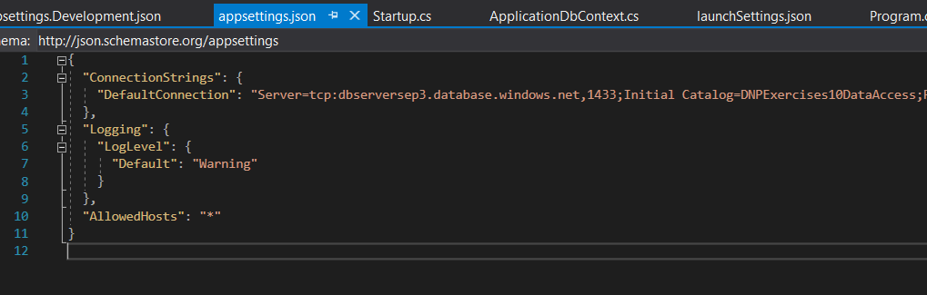

# dependency injection of the DbContext

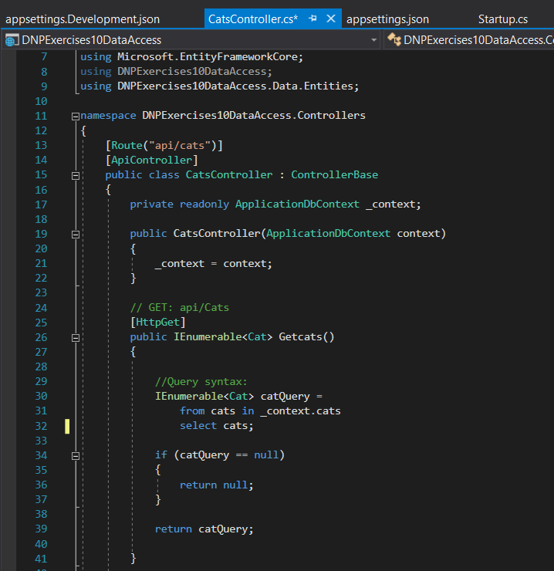

# Model

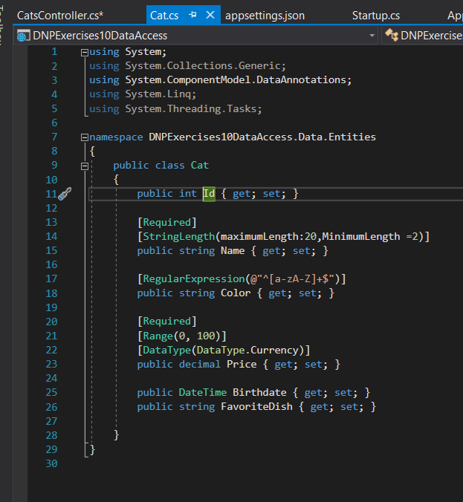

# Configuring DbContext to use connection string

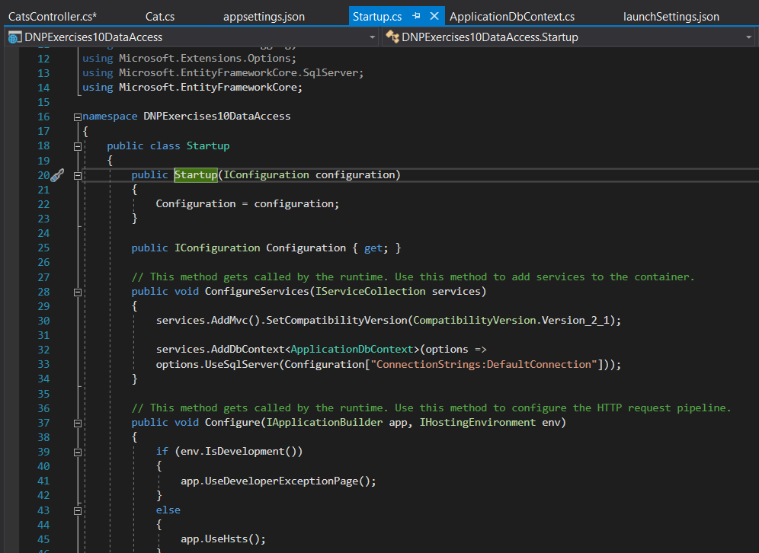

# Initialize the DbContext in main method

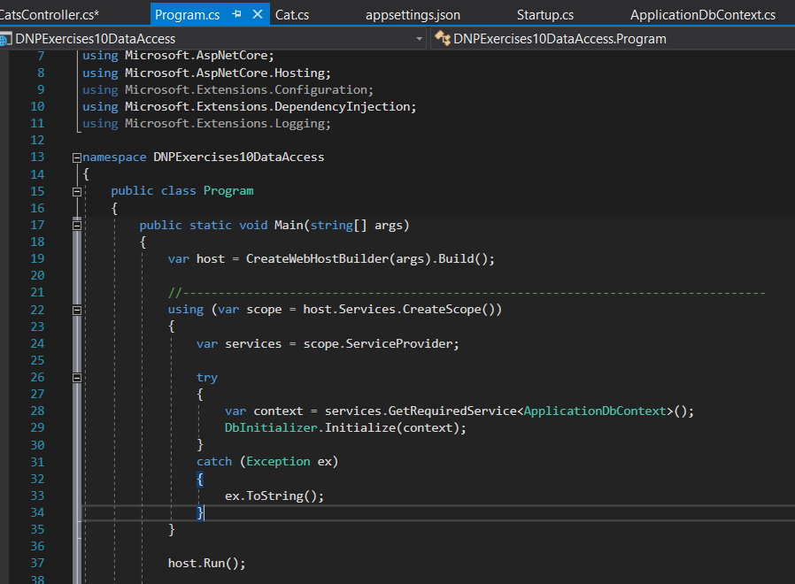

# Add initial migration

# Dotnet ef migrations add initial

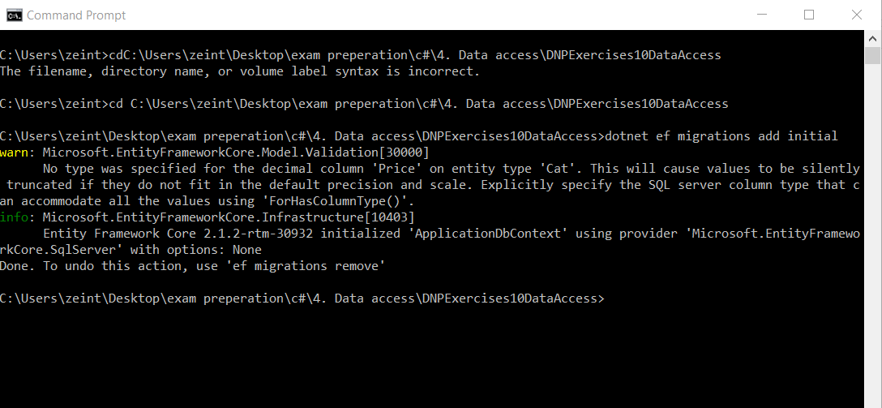

# Update database schema

# Dotnet ef database update

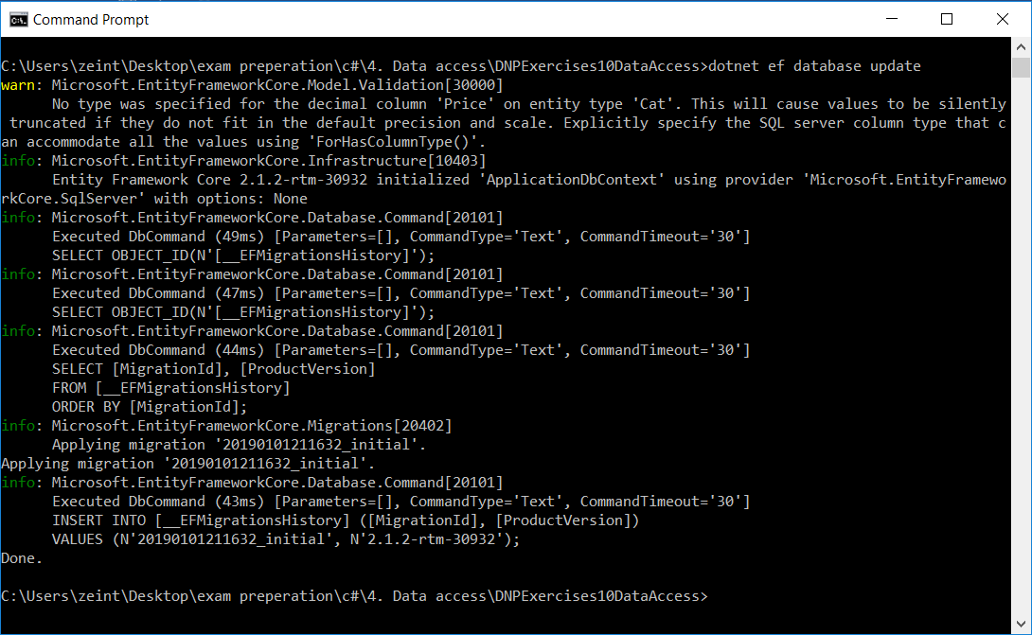

# Azure Database

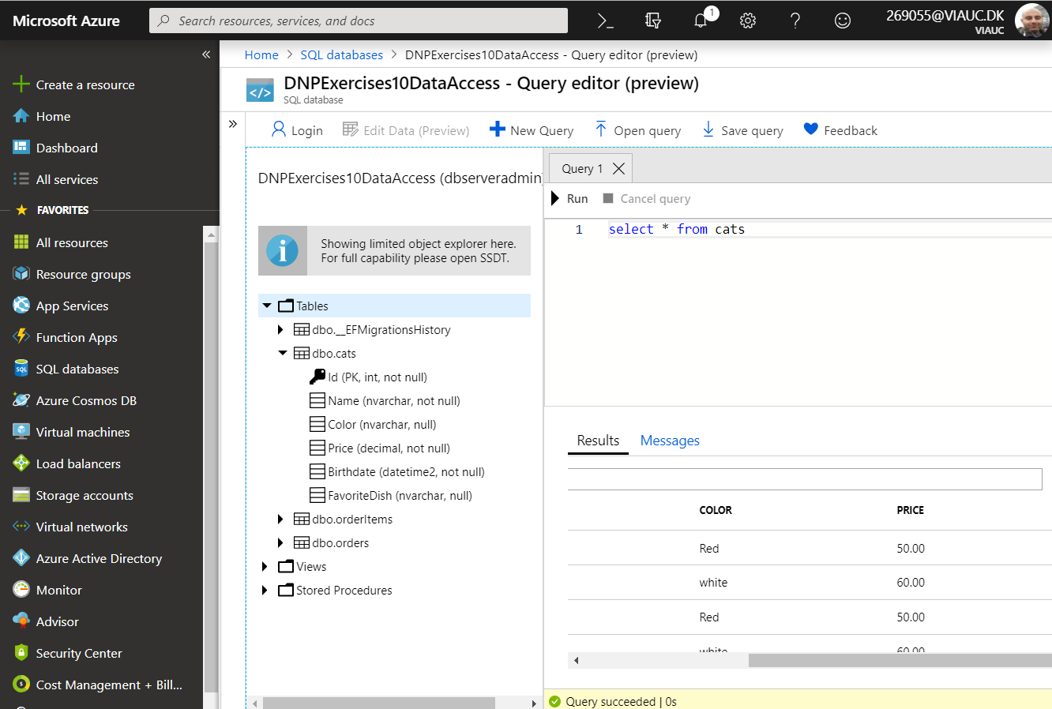

# LINQ Method syntax vs Query syntax:

